**Course Analysis:**

In this steps k-means clustering algorithm was applied to the proposed data an get valuable information, k- means is an old and most widely used by clustering algorithm. Course mark Consisting of three parts:

Practical Mark 30%, Midterm Mark 20%, Final Mark 50%

1. Select K points as the initial centroids:

Center1=Low{MidMark,LabMark,FinalMark}

Center2=Medim{MidMark,LabMark,FinalMark}

Center3=High{MidMark,LabMark,FinalMark}

1. From K- cluster by assigning all **Marks** to the closest centroids
2. Recomputed the centroid of each cluster.

**Results:**

We grouped the students regarding their final grades in three ways:

1. Assign possible labels that are the same as number of possible grades

2. Group the students in three classes “High”, “Medium”, “Low”.

3. Categorized the students with one of two class labels “Passed” for marks greater than or equal to 40 and “Failed” for marks less than 40

**Table1** Number and percentage of students regarding to class obtained

|  |  |  |  |
| --- | --- | --- | --- |
| Class | Marks | No.OF.students | Percentage |
| A+ | 98-100 | 3 | 3% |
| A | 95-100 | 8 | 6% |
| A- | 90-95 | 3 | 3% |

…………

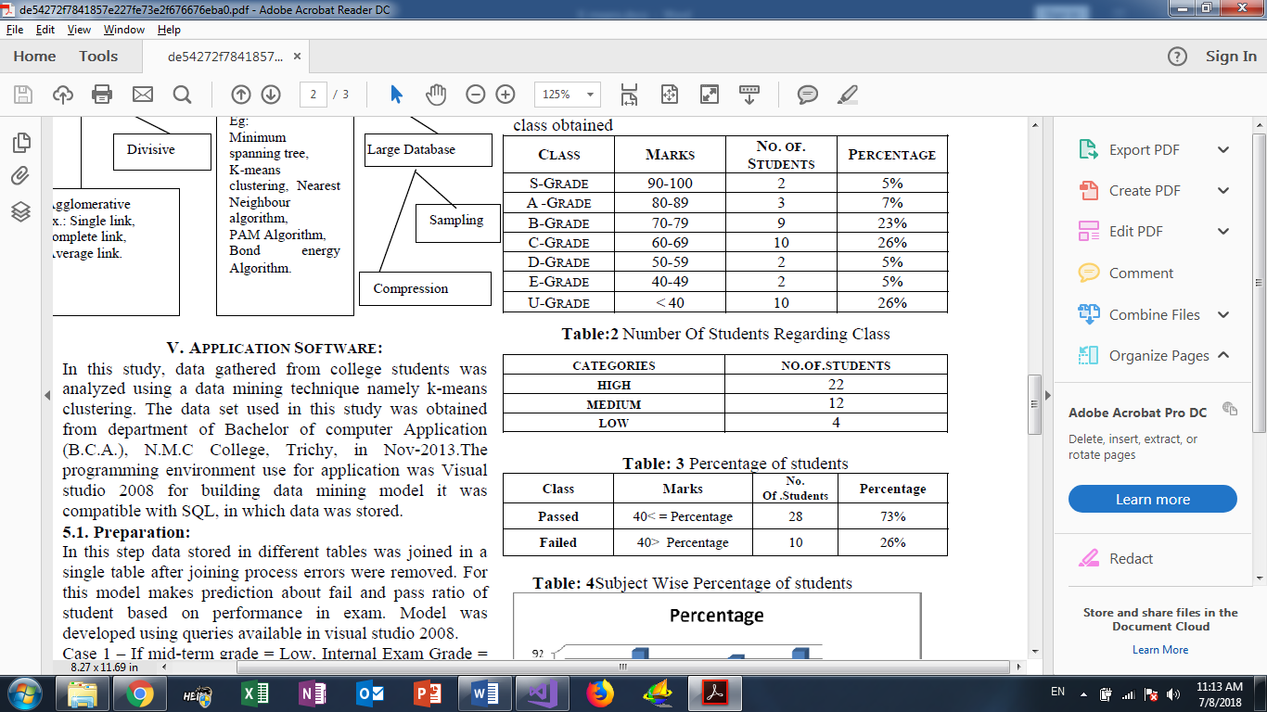

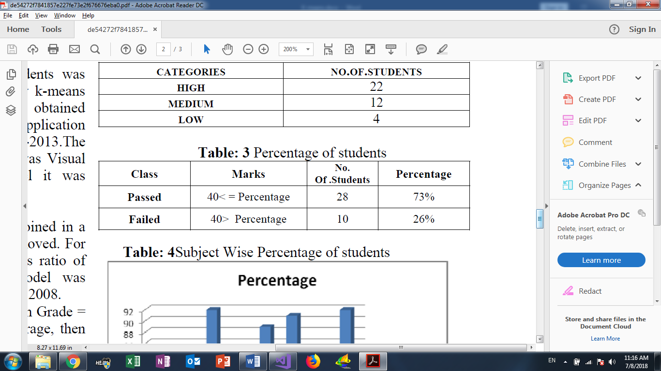

**Exam Analysis:**

To Analysis any Exam we should understand how the teacher choice exam question, so the course consists of ILOS. Each ILO consists of Topics like this:

Course

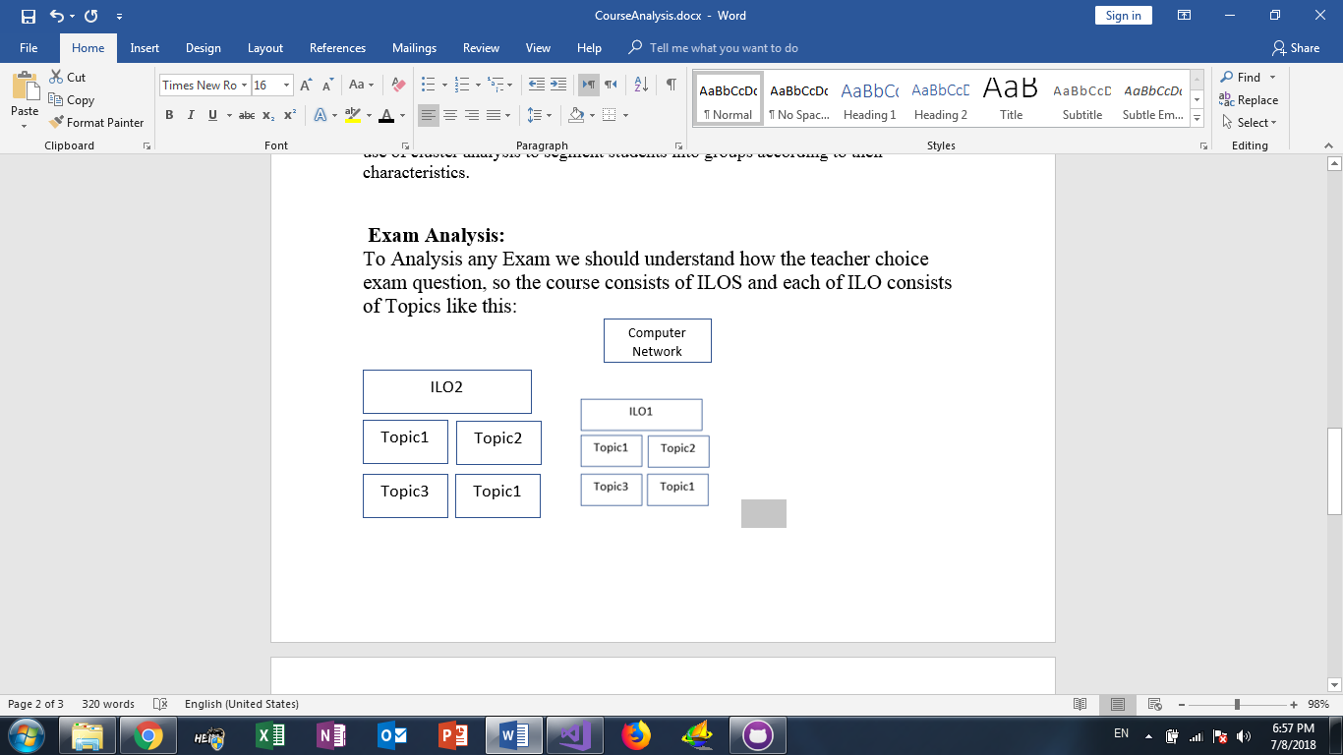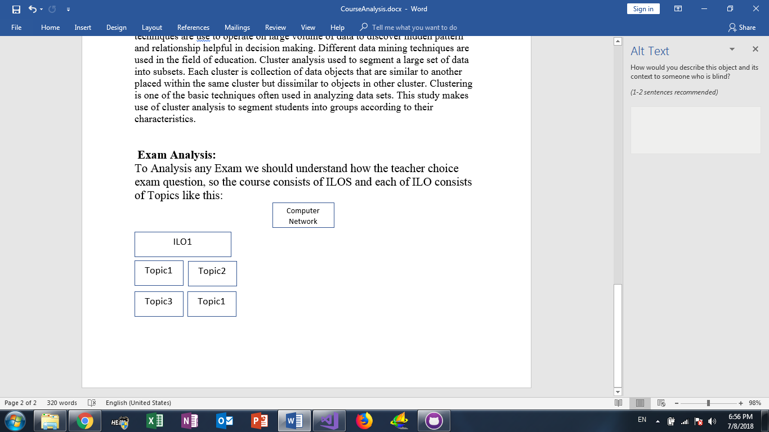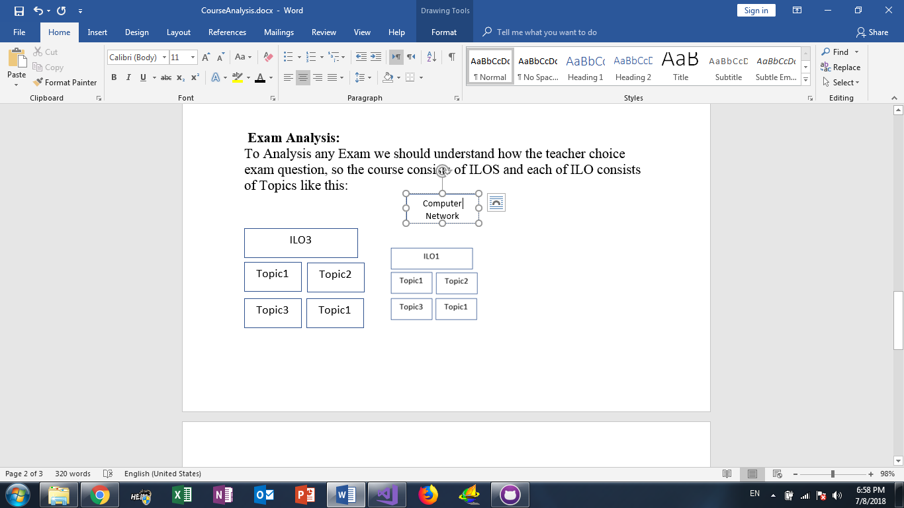

|  |  |
| --- | --- |
|  |  |

So, when we analysis the exam we need to Know the success percentage of each ILO and success percentage of each Topic in ILO. let we suppose the Exam consists of three ILOS and these are success percentage

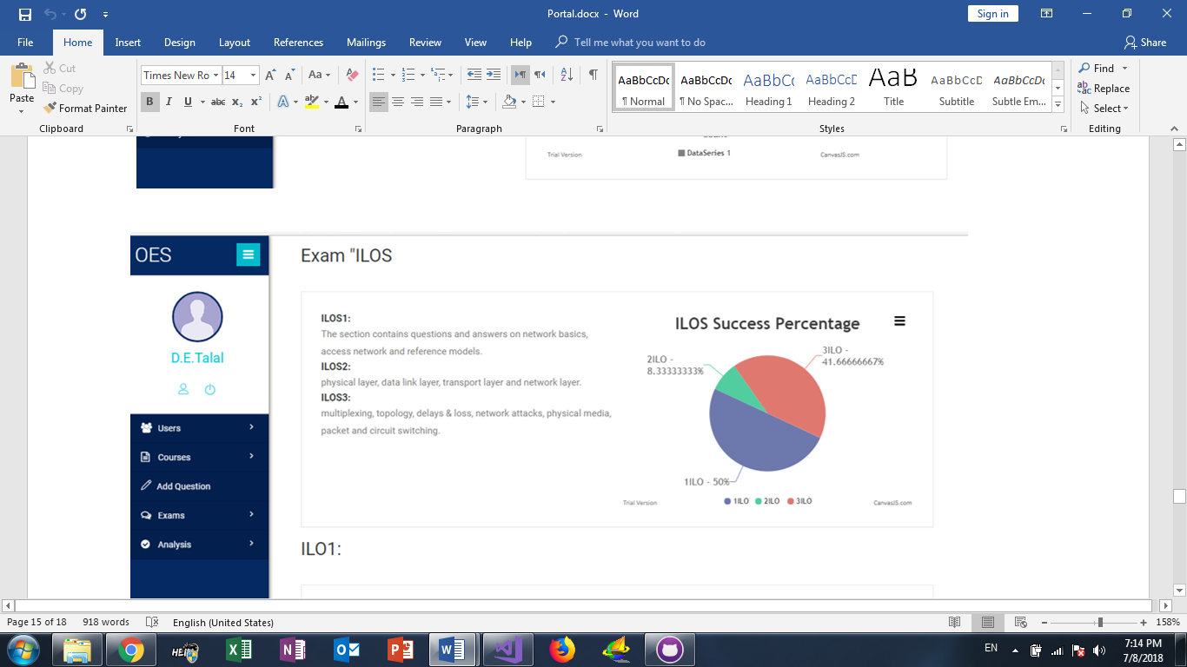

From previous picture we Know:

Success percentage in ILO1 is 50%

Success percentage in ILO2 is 8%

Success percentage in ILO3 is 41%

Now for each ILO more than 1 topic and each topic have success percentage:

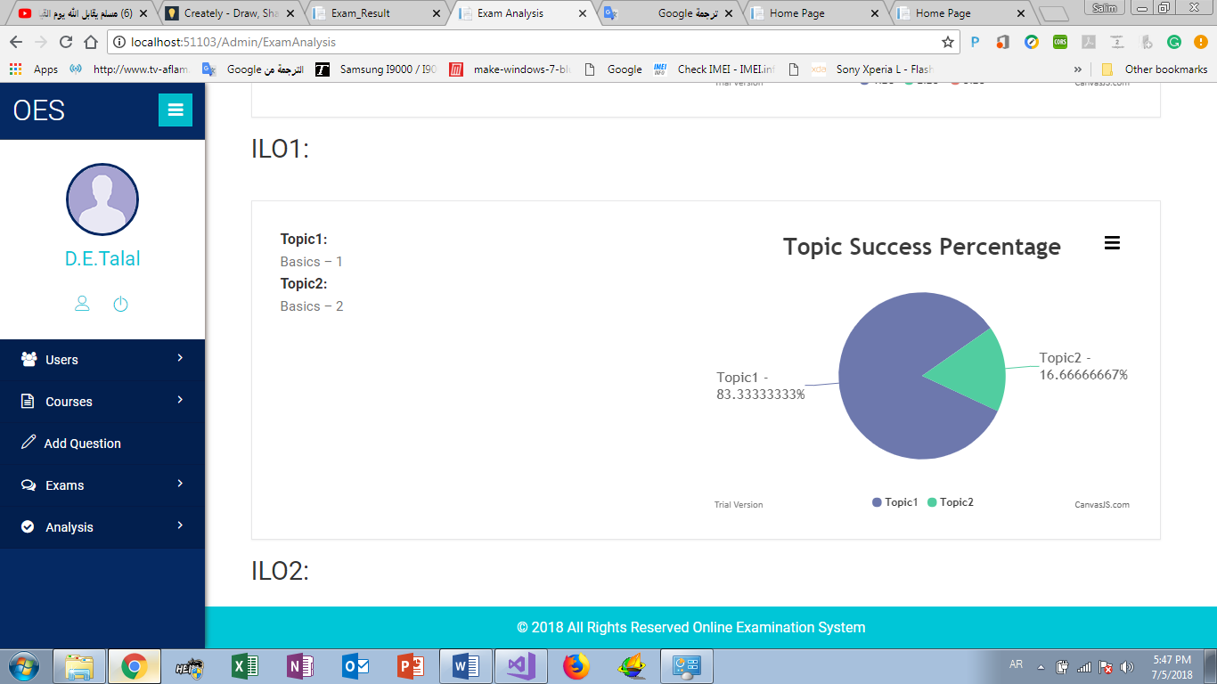ILO1 Topics:

So, the success percentage of ILO1 is 50% and ILO1-topic1 success percentage is 83%, ILO1-topic2 success percentage is 17%

Form these information’s the teacher can get a general picture about exam.

**Student Analysis:**

Student registered more than 3 courses in each semester, for each course some information:

Students Mark

Students Attendance percentage

Students success Rate

…….

And a lot of things, but for students it’s a good idea to have all student information in one page like:

Student Attendance percentage in all courses, Best mid Marks, Best final mark, Best Practical mark, worst mid Marks, worst final mark, worst Practical and the best course in the semester

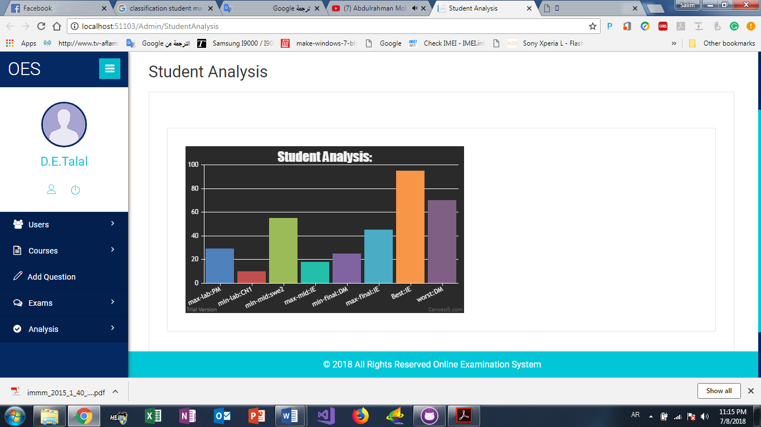

**CONCLUSION:**

Analysis and Data mining allows the user to analyze data from different dimensions categorize it and summarize the relationship. Identify during mining process. Data mining techniques are use to operate on large volume of data to discover hidden pattern and relationship helpful in decision making. Different data mining techniques are used in the field of education. Cluster analysis used to segment a large set of data into subsets. Each cluster is collection of data objects that are similar to another placed within the same cluster but dissimilar to objects in other cluster. Clustering is one of the basic techniques often used in analyzing data sets. This study makes use of cluster analysis to segment students into groups according to their characteristics.